www.holylandssuntours.com | info@holyandssuntours.com


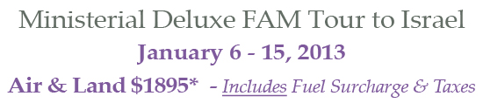

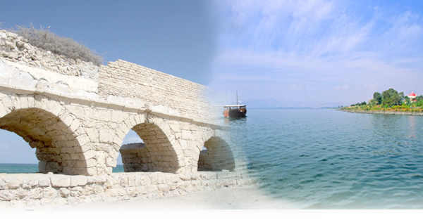
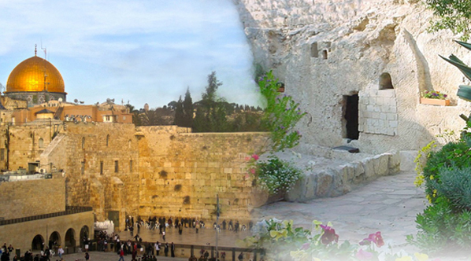
Tour Includes
• Roundtrip air from JFK to Tel-Aviv
• 1 night Tel-Aviv – Herods Hotel
• 3 nights Tiberias – Leonardo Plaza (former Sheraton Plaza)
• 4 Nights Jerusalem – Leonardo Plaza (former Sheraton Plaza)
• 15 Meals: 7 Breakfasts plus 8 Dinners
• 7 Days of Comprehensive Sightseeing Including: Joppa, Caesarea Maritima, Mount Carmel, Acre, Mount of the Beatitudes, Church of the Primacy, Dan, Nazareth, Mary’s Well, Precipice, Megiddo, Beit She’an, Qsar-el-Yehud, Israel Museum, Model City, Southern Excavations, Western Wall, Rabbinic Tunnel, Upper Room, Burnt House, Herodium, Bethlehem, Shepherds’ Fields, Ein Gedi, Masada, Qumran, Dead Sea Swim, Mount of Olives, Garden of Gethsemane, Jerusalem's Old City, House of Caiaphas, Pool of Bethesda, Via Dolorosa, Holy Sepulchre, Garden Tomb and much more ...
• Roundtrip transfers
• Professional Guide plus an Exclusive Bus & Driver
• Fully Escorted by a Holy Lands Sun Tours Representative
For more information please CLICK HERE
Minister’s Base Cost of FAM Tour – Excluding Fuel Surcharge, Taxes and Tips – is REFUNDABLE if you return to Israel with a group of 20 or more guests within 18 months on a Holy Lands Sun Tours customized tour.
Space is limited to 20 Ministers! Call now to reserve your space:
800-942-2114 or 607-862-5033 or E-mail: cegan@isram.com
* Prices are Per Person, Air & Land, sharing double room and includes Fuel Surcharge and Airport Taxes of $447.00 (subject to change until ticketing). Airfare is based on Turkish Airline and subject to confirmation. Add-on fares are not available. Departure is only from JFK New York. Spouses are permitted at a cost of an additional $200.00. Gratuities of $130.00 are not included.
